**TUTORIAL 5**

1. Consider the following activity dependency table.

|  |  |  |
| --- | --- | --- |
| **Activity** | **Duration (days)** | **Predecessor** |
| A | 3 |  |
| B | 2 | A |
| C | 5 | B |
| D | 7 | B, C |
| E | 4 | B |
| F | 5 | D |
| G | 3 | E |
| H | 2 | F |
| I | 6 | F |
| J | 3 | G |
| K | 5 | H, I, J |

1. Draw a network activity diagram for the information above.
2. Identify the critical path and its duration.
3. Calculate ES, EF, LS and LF.
4. Determine the slack for each activities and the total slack.

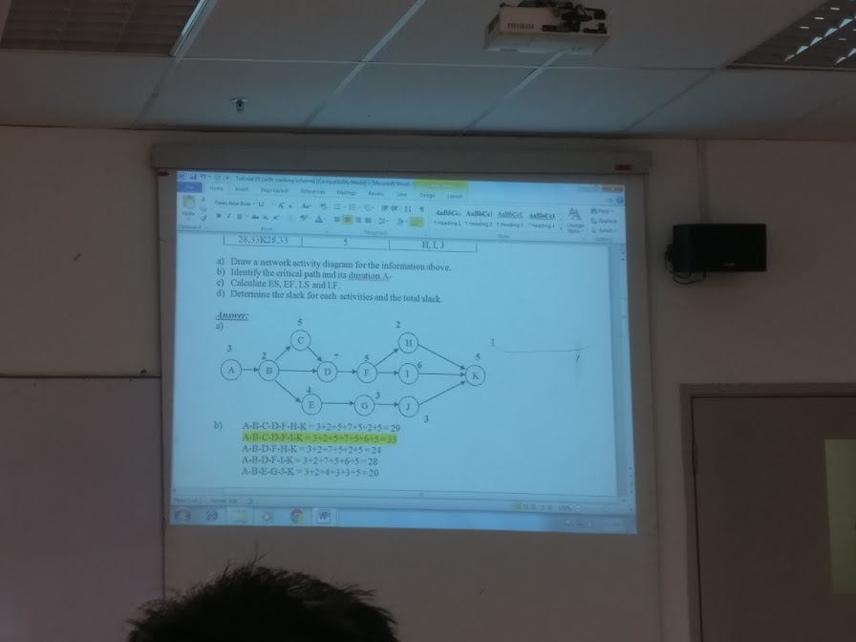

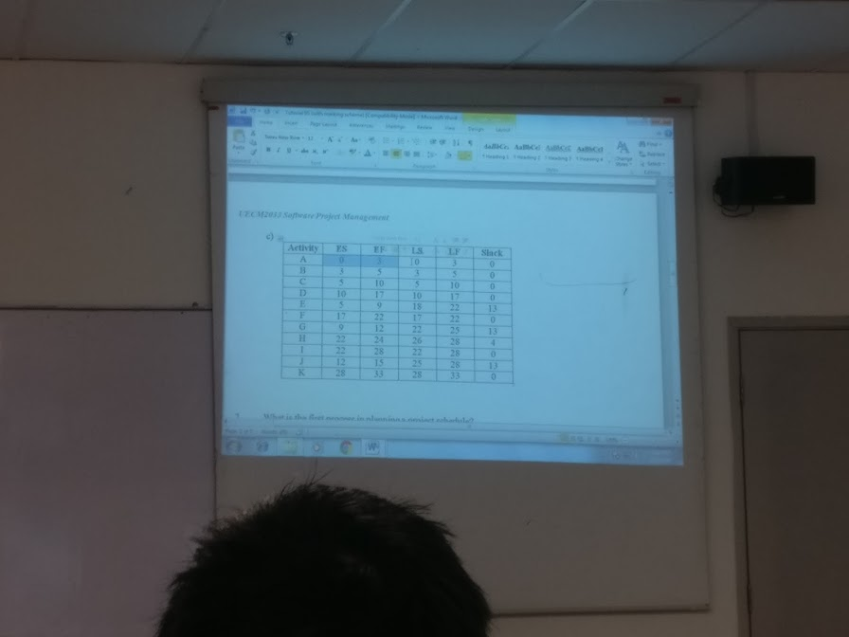

1. What is the first process in planning a project schedule?
2. Defining milestones b) Defining activities

c) Estimating activity resources d) Sequencing activities

1. As the project manager for a software development project, you are helping to develop the project schedule. You decide that writing code for a system should not start until users sign-off on the analysis work. What type of dependency is this?
2. technical b) mandatory c) discretionary d) external
3. Which of the following statements is false?
4. A resource breakdown structure is a hierarchical structure that identifies the project’s resources by category and type
5. Duration and effort are synonymous(same) terms
6. A three-point estimate is an estimate that include an optimistic, most likely, and pessimistic estimate
7. A Gantt chart is a common tool for displaying project schedule information
8. _____________ is a network diagramming technique used to predict total project duration.
9. PERT b) Gantt chart c) Critical path method d) Crashing
10. Briefly describe the following terms in project time management.
11. Critical path: Earliest time the program can be finished
12. Float : the amount of time an activity may be delayed without delaying a succeeding activity or the project finish date
13. Merge : occurs when two or more nodes precede a single node
14. Crashing